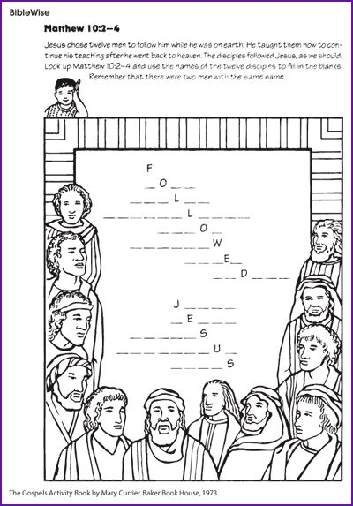

Matthew 10:2-4 New Living Translation (NLT)
² Here are the names of the twelve apostles:
first, Simon (also called Peter), then Andrew (Peter’s brother),
James (son of Zebedee), John (James’s brother), ³ Philip,
Bartholomew, Thomas, Matthew (the tax collector), James (son of Alphaeus), Thaddaeus,^{[a] 4} Simon (the zealot^{[b]}),
Judas Iscariot (who later betrayed him).
