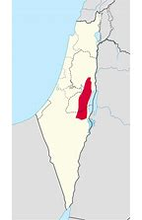

See all images
Judaean Desert
Desert
The Judaean Desert or Judean Desert is a desert in Israel and the West Bank that lies east of Jerusalem and descends to the Dead Sea. It stretches from the northeastern Negev to the east of Beit El, and is marked by natural terraces with escarpments. It ends in a steep escarpment dropping to the Dead Sea and the Jordan Valley. The Judaean Desert is crossed by numerous wadis from northeast to southeast and has many ravines, most of them deep, from 366 metres in the west to 183 metres in the east. The Judaean Desert is an area with a special morphological structure along the east of the Judaean Mountains.

