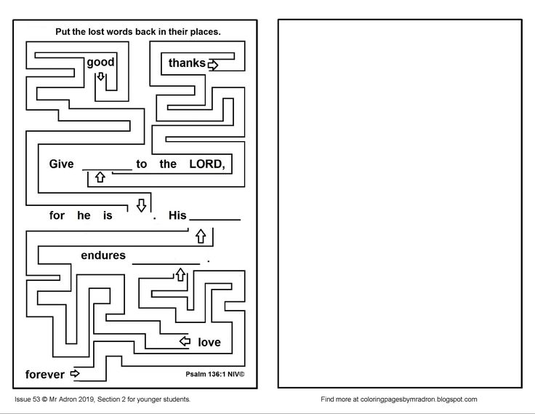
Write the verse here:

Give… __________________
________________________
_________________________
__________________________
__________________________
_________________________

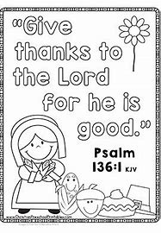
Use this page as a Gratitude Journal for a day. Write down or draw a picture of the things you are thankful for.

Thank you, God!

