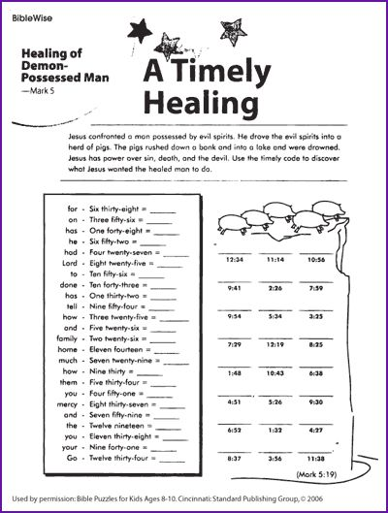

Mark 5:18-20
¹⁸ While he was climbing into the boat, the one who had been demon-possessed pleaded with Jesus to let him come along as one of his disciples. ¹⁹ But Jesus wouldn’t allow it. “Go home to your own people,” Jesus said, “and tell them what the Lord has done for you and how he has shown you mercy.” ²⁰ The man went away and began to proclaim in the Ten Cities all that Jesus had done for him, and everyone was amazed.

