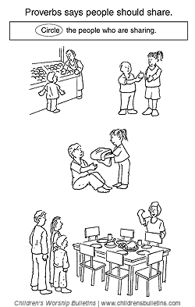
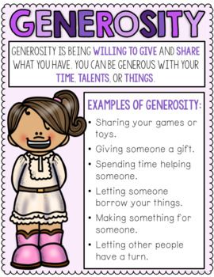
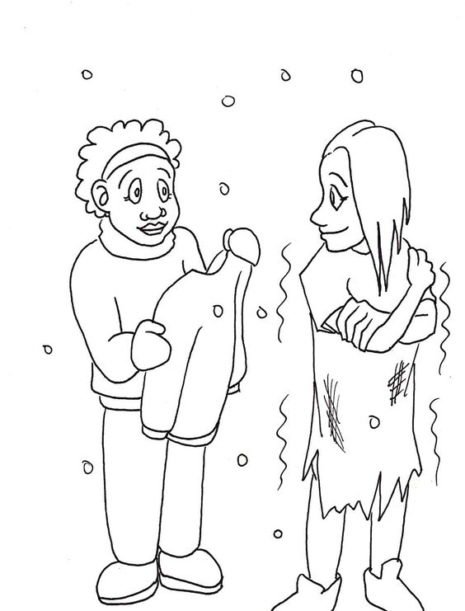

* * * * * * * * * * * *
List some ways that you can be generous this week. Start by thinking about how your five senses might help you think of ways to be generous: sight, hearing, touch, taste, smell.

